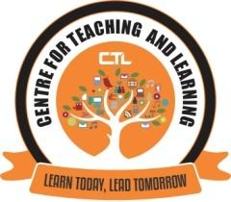
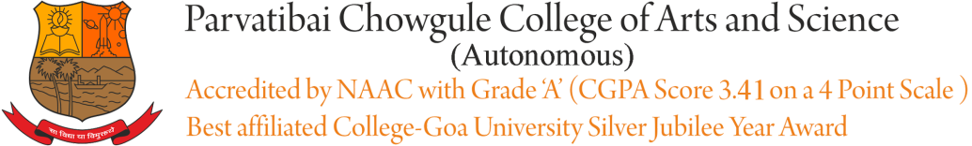

CENTRE FOR TEACHING AND LEARNING

REPORT ON
EXPERT WEBINAR FDP SERIES-III
Title: | PREPARING FOR REMOTE TEACHING LEARNING: SHARING EXPERIENCES
Date and year: | 5th October, 2020  3.30pm to 5pm via Zoom
Venue: | Conference Hall/Live Webinar via ZOOM
Resource person/s: | Dr.Aparna Katre,  Associate Professor of Cultural Entrepreneurship, Department of World Languages and Cultures, College of Liberal Arts, University of Minnesota - Duluth, USA
Organising Committee | CTL
No. of Participants: | 23
Objective: | Sharing of Experiences wrt Remote TLE from Foreign Universities;  Exposure to the Faculty to various online TLE Trends
Summary of the proceedings: | The Resource Person focused on three main areas in her webinar. They are listed as follows:  1.Thinking about Curriculum  2. Student Engagement  3. Student Feedback-Formative & Summative  The Resource People also answered/addressed queries and had online interactions with the faculty in-between her session and also in the end.
Photographs:

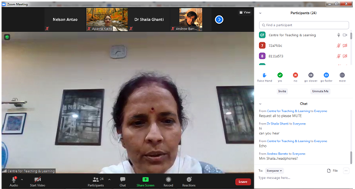
Dr. Shaila Ghanti, Offg Principal welcomed the resource person along with all the participants present for the session.

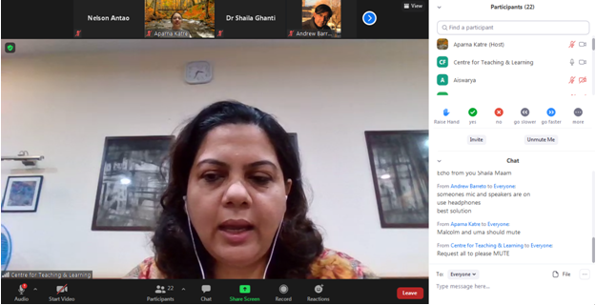
Dr. Sameena Falleiro, Coordinator - CTL(Centre for Teaching learning), introduced the resource person to all the participants

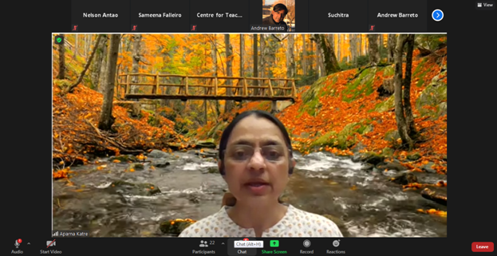
Dr. Aparna Katre, Resource person delivering the session on Preparing for Remote Teaching Learning

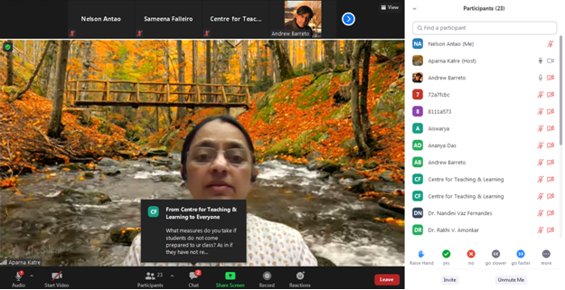
Dr. Aparna Katre, while delivering the session also addressed all the questions raised by the faculty’s

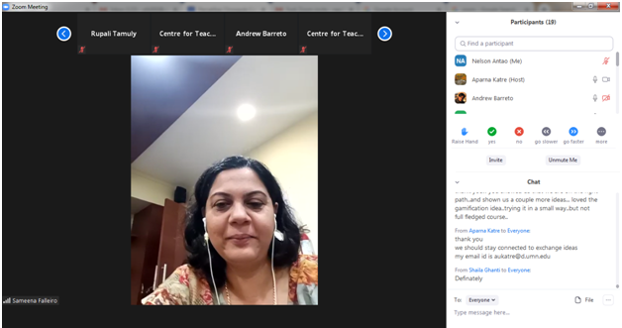
Dr. Sameena Falleiro delivered vote of thanks to the resource person and participants on behalf of the principal

Report Prepared by:
Dr. Sameena Falleiro & Mr.Nelson Antao

